EXPT NO:2 | Regression and Optimization (Linear and Logistic regression)
DATE: 28.01.2026

PRE-LAB QUESTIONS (PROVIDE BRIEF ANSWERS TO THE FOLLOWING QUESTIONS)
- What is regression analysis, and how is it used to predict continuous values such as ocean temperature in linear regression?
Regression analysis models relationships between variables to predict continuous outcomes. Linear regression estimates a straight-line relationship, e.g., predicting ocean temperature from time, depth, or location.

- How does logistic regression differ from linear regression in terms of:
(a) type of output produced
Linear regression outputs continuous values
logistic regression outputs probabilities between 0 and 1.
(b) type of problems it is used to solve?
Linear solves regression problems
logistic solves classification problems.

- In a regression equation
$$y=β_{0}+β_{1}x_{1}+β_{2}x_{2}+⋯+β_{n}x_{n}$$
what does each regression coefficient $β_{i}$indicate about the corresponding feature?
Each coefficient βᵢ represents the expected change in output y for a one-unit increase in feature xᵢ, assuming all other features remain constant.

- Why is feature scaling (standardization or normalization) necessary before applying:
(a) gradient-descent-based linear regression
Gradient descent converges faster and more stably when features share similar scales.
(b) logistic regression?
Logistic regression optimization becomes numerically stable and efficient.

- What is a cost function, and how is it used to evaluate the performance of a regression model?
A cost function measures the difference between predicted and actual values, summarizing model error. It guides training by indicating how well the regression model performs.

- What is optimization in machine learning, and what does it mean to minimize a loss function?
Optimization is the process of adjusting model parameters to minimize a loss function, meaning finding parameter values that produce the lowest prediction error.

- Why is gradient descent preferred over solving equations directly when training regression models on large datasets?
Gradient descent is preferred for large datasets because solving equations directly is computationally expensive, while gradient descent efficiently approximates optimal parameters using iterative updates.

- What is overfitting in regression models, and how does regularization (Ridge/Lasso) help reduce it?
Overfitting occurs when a model learns noise instead of patterns. Ridge and Lasso regularization reduce overfitting by penalizing large coefficients and simplifying the model.

IN-LAB EXERCISE
OBJECTIVE:
To implement and optimize linear regression and logistic regression models using real-world datasets and analyze their performance.

SCENARIO 1:
Predict ocean water temperature using environmental and depth-related features.
Dataset (Kaggle – Public):
https://www.kaggle.com/datasets/sohier/calcofi
Target Variable:
- Water Temperature (T_degC)
Sample Input Features
- Depth (m)
- Salinity
- Oxygen
- Latitude
- Longitude

IN-LAB TASKS
- Import necessary Python libraries (NumPy, Pandas, Matplotlib, Seaborn, Scikit-learn).
- Load the CalCOFI dataset into a Pandas DataFrame
- Select relevant numerical features and target variable.
- Handle missing values using mean/median imputation.
- Perform feature scaling using StandardScaler.
- Split the dataset into training and testing sets.
- Train a Linear Regression model using Scikit-learn.
- Predict water temperature for test data.
- Evaluate model performance using:
– Mean Squared Error (MSE)
– Root Mean Squared Error (RMSE)
– R² Score
- Visualize:
– Actual vs Predicted temperature
– Residual errors
- Optimize model performance using:
– Feature selection
– Regularization (Ridge / Lasso)

SCENARIO 2:
Classify whether LIC stock price will increase (1) or decrease (0) based on historical data.
Dataset (Kaggle – Public):
https://www.kaggle.com/datasets/debashis74017/lic-stock-price-data
Target Variable (Derived):
• Price Movement
– 1 → Closing price > Opening price
– 0 → Closing price ≤ Opening price
Input Features:
• Open
• High
• Low
• Volume

IN-LAB TASKS (Logistic Regression)
- Import required Python libraries.
- Load LIC stock dataset into Pandas.
- Create a binary target variable (Price Movement).
- Handle missing values.
- Perform feature scaling.
- Split the dataset into training and testing sets.
- Train a Logistic Regression model.
- Predict stock movement for test data.
- Evaluate classification performance using:
– Accuracy
– Precision
– Recall
– F1-Score
– Confusion Matrix
- Visualize:
– ROC Curve
– Feature importance
- Optimize model using:
– Hyperparameter tuning (C, penalty)
– Regularization

Code & Output
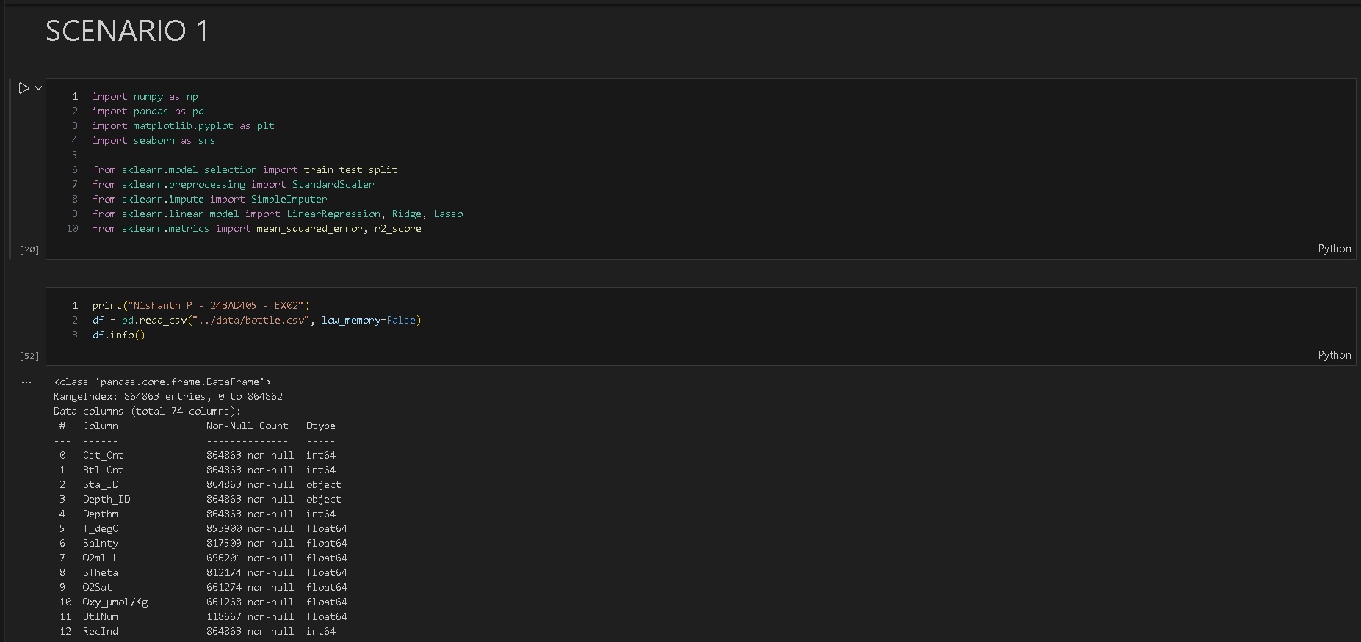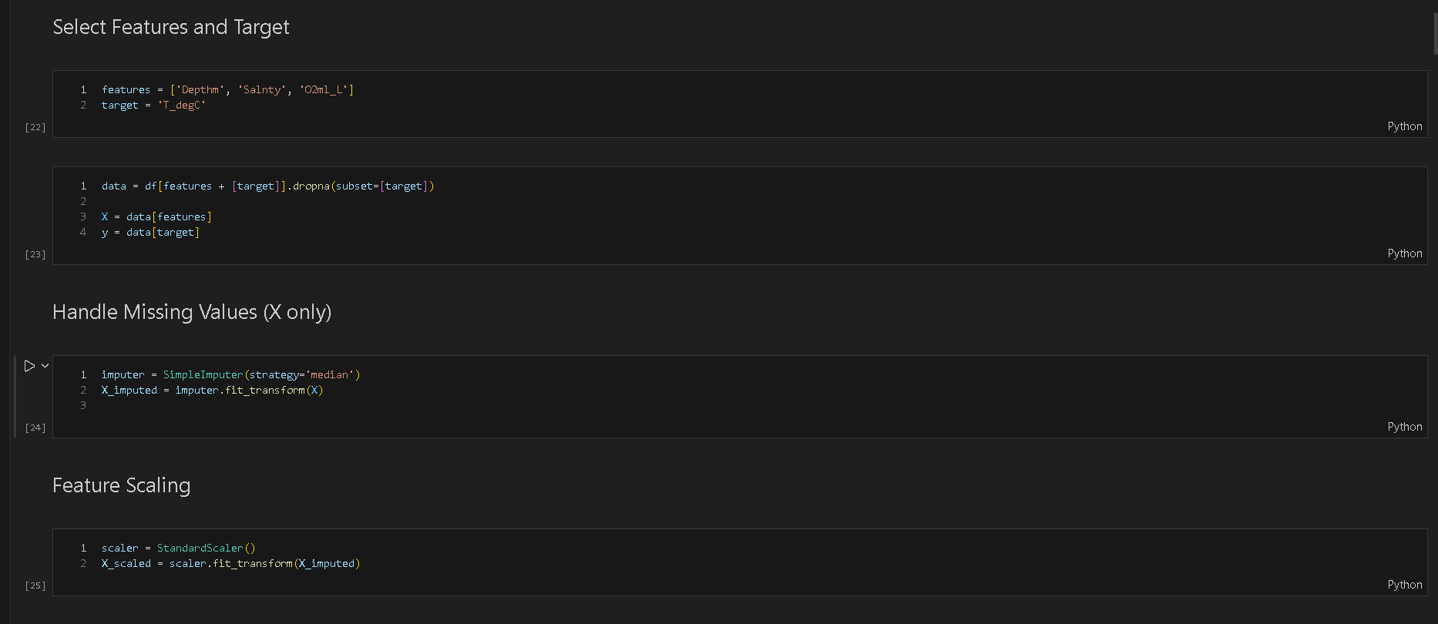
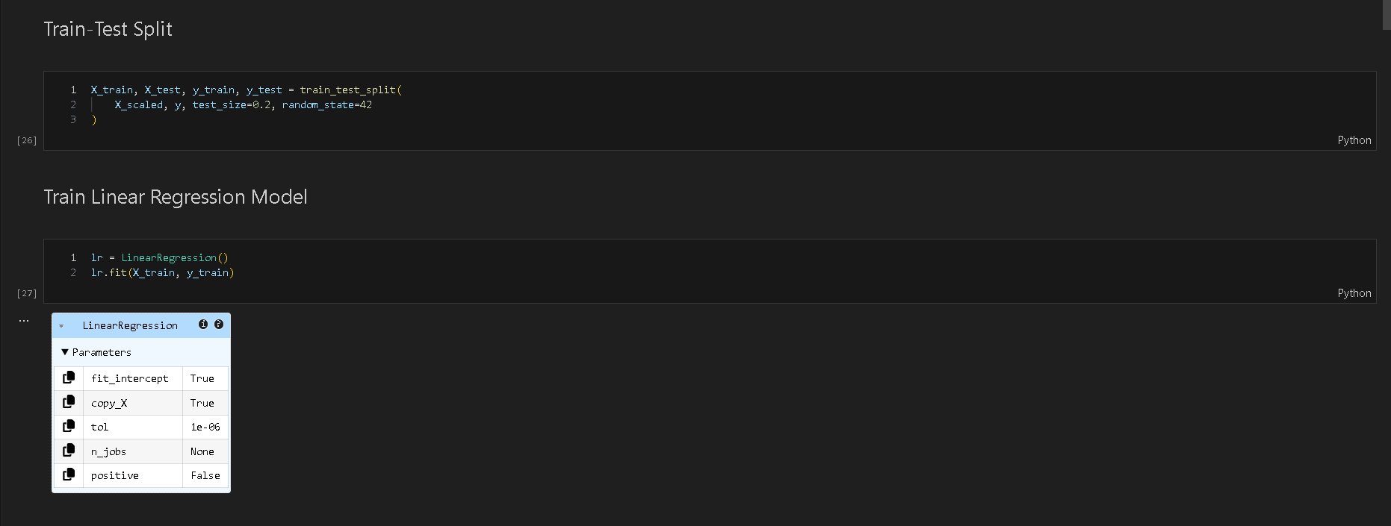
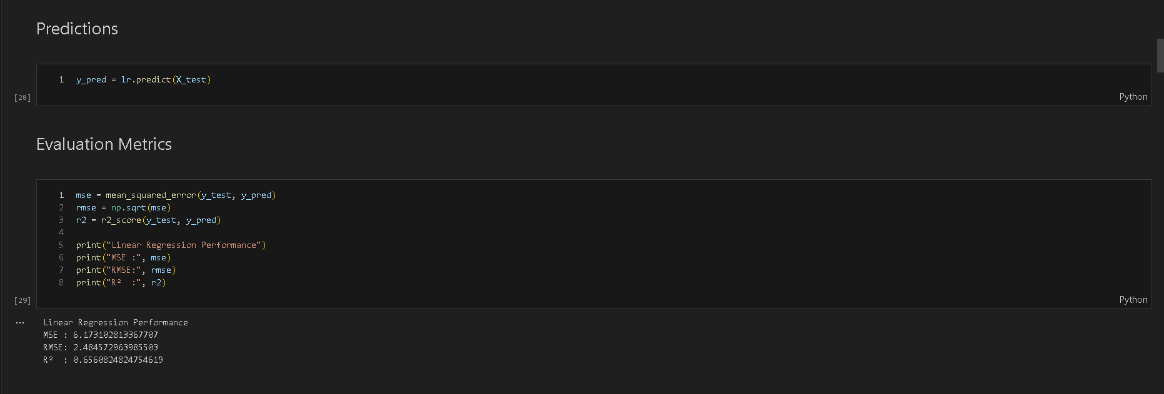
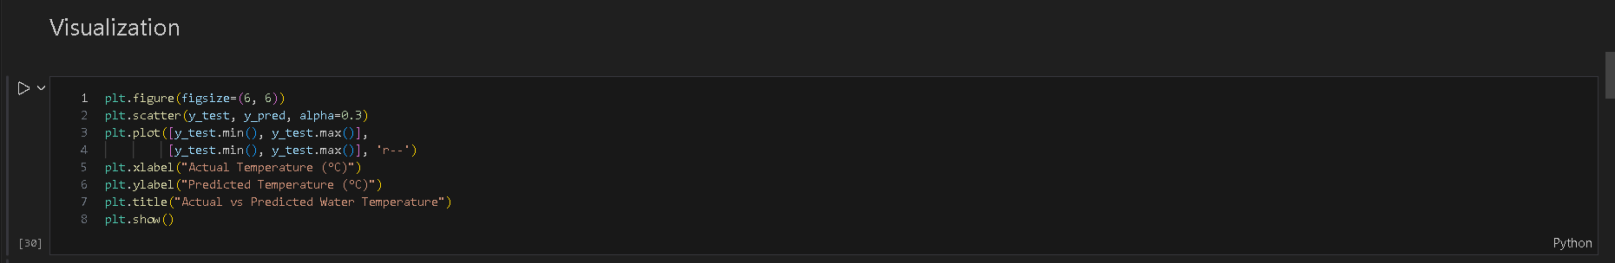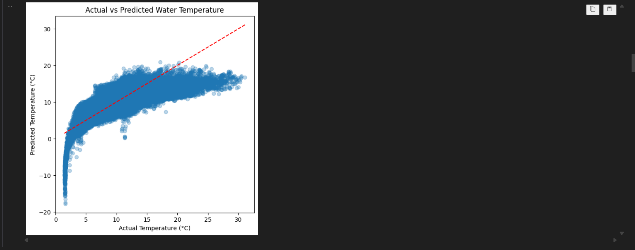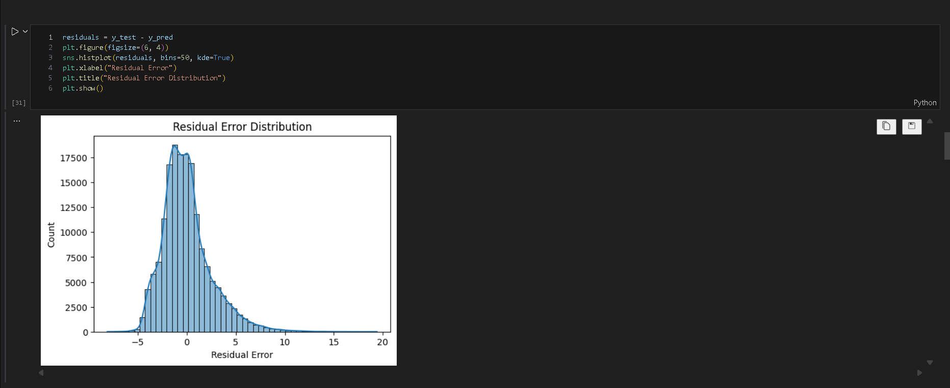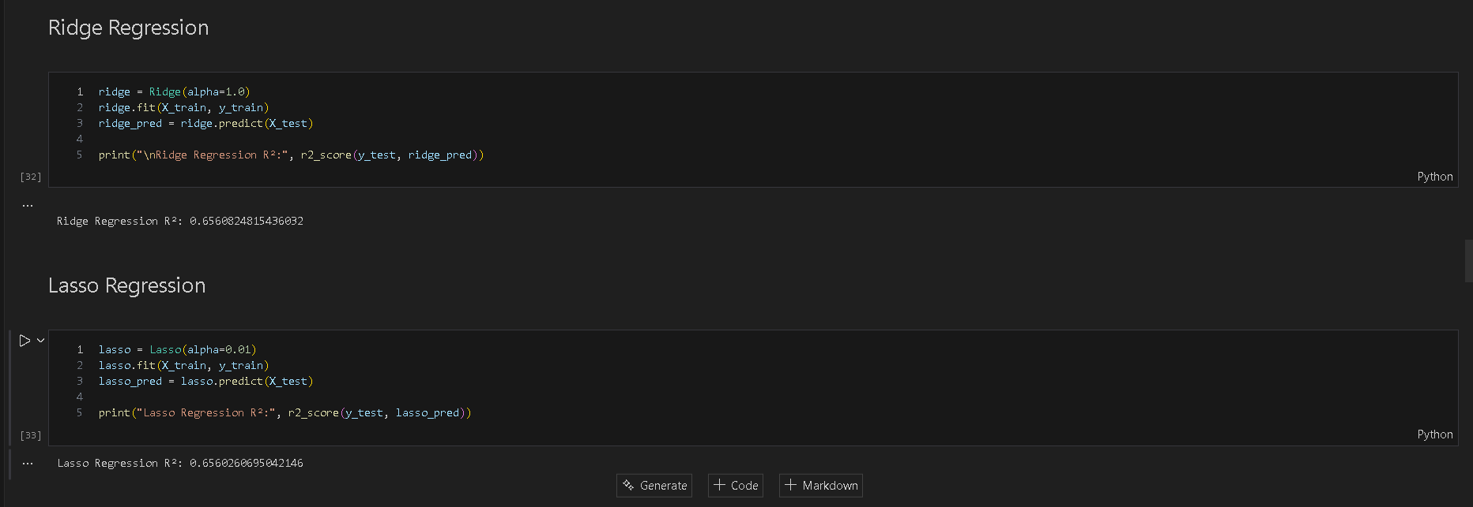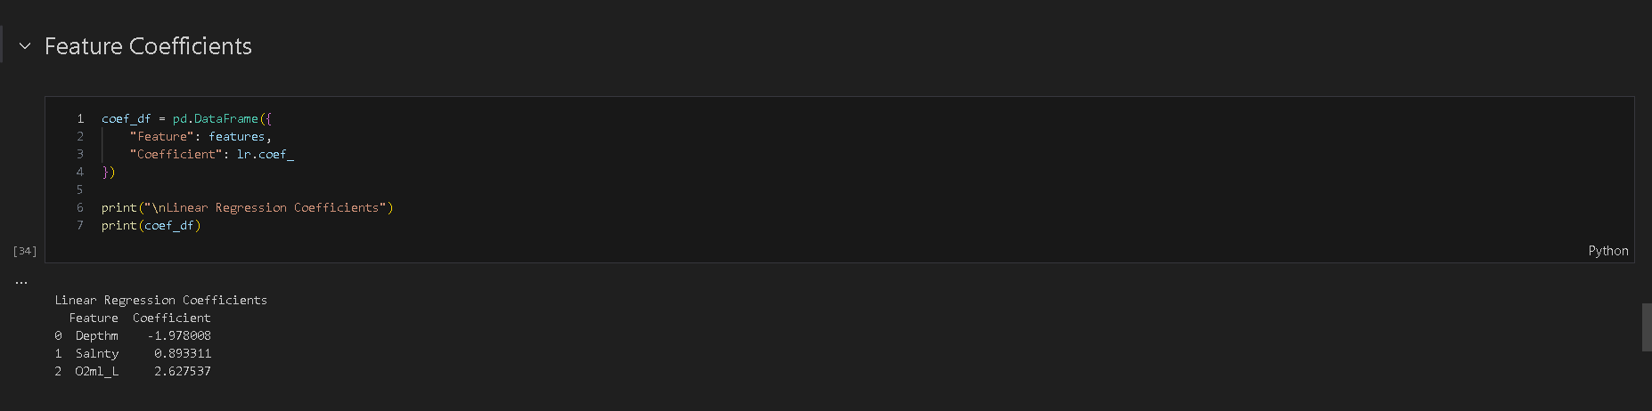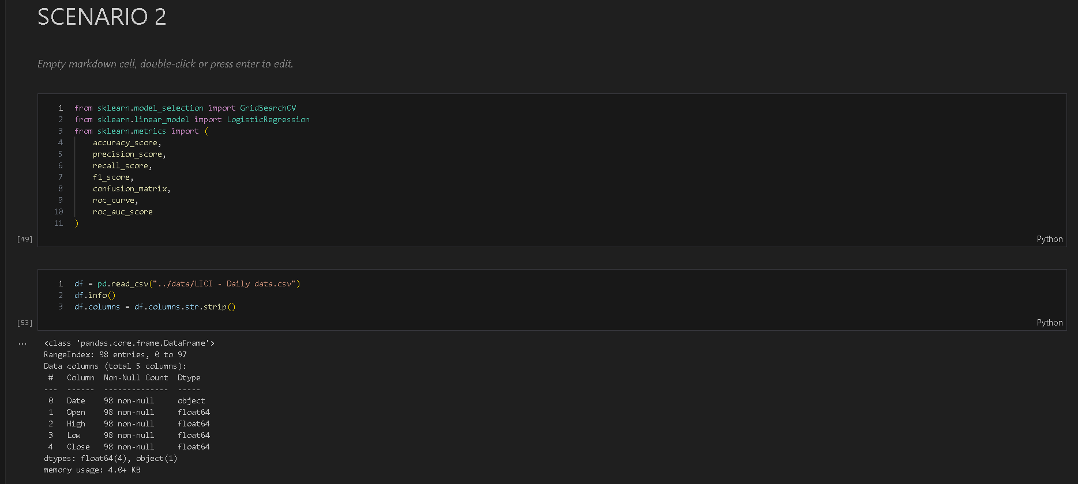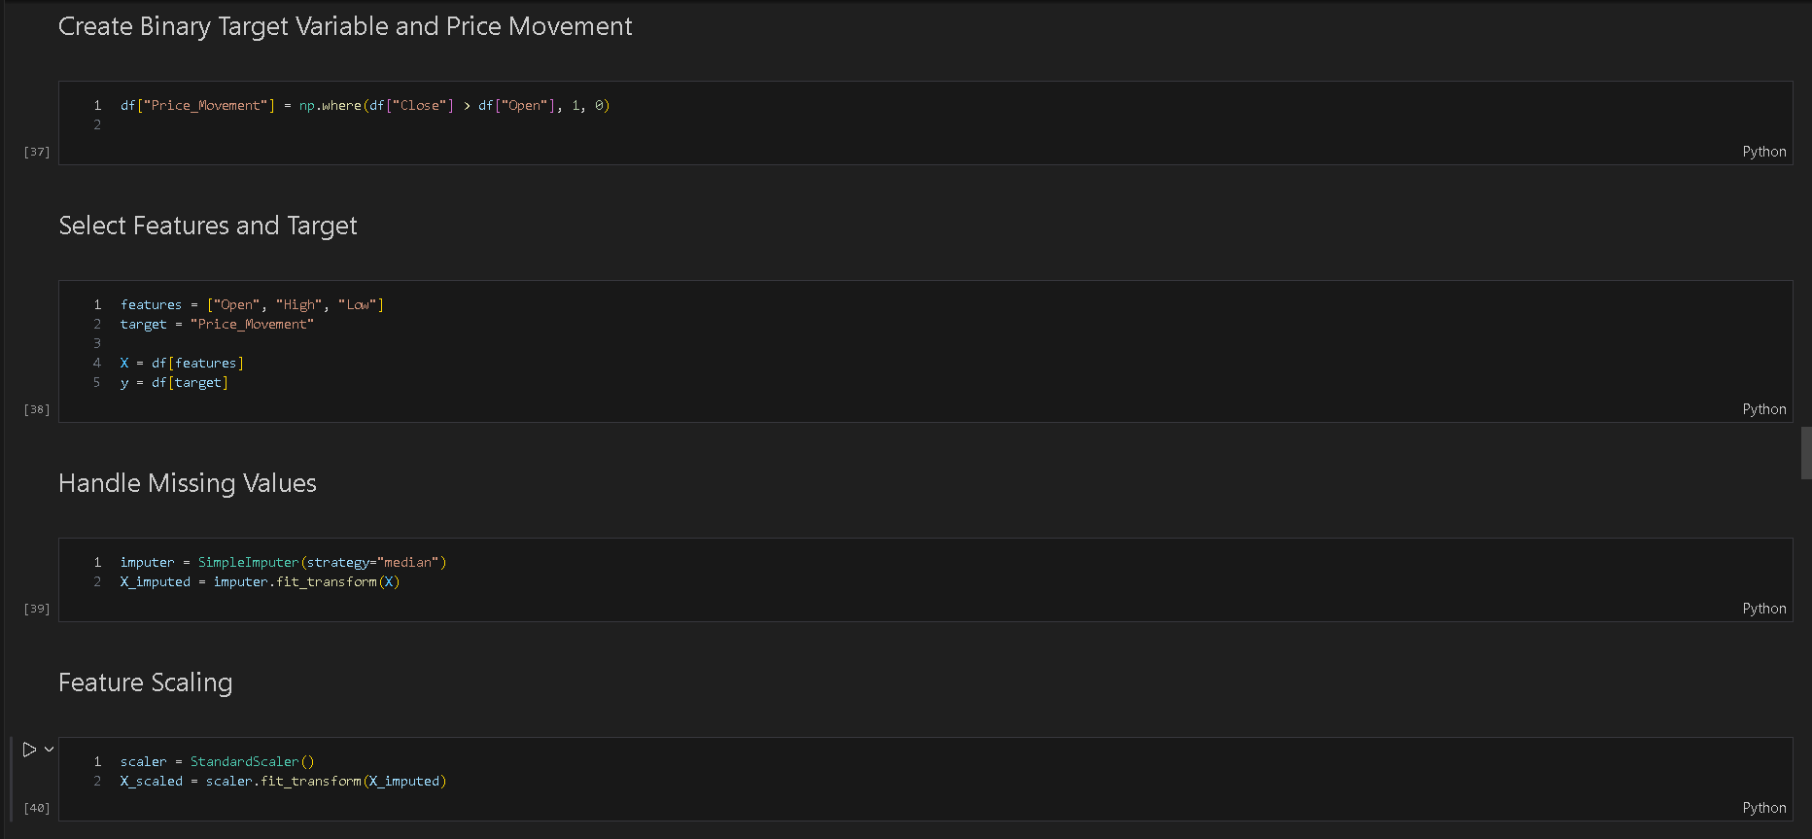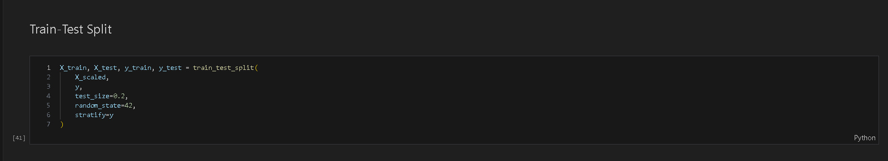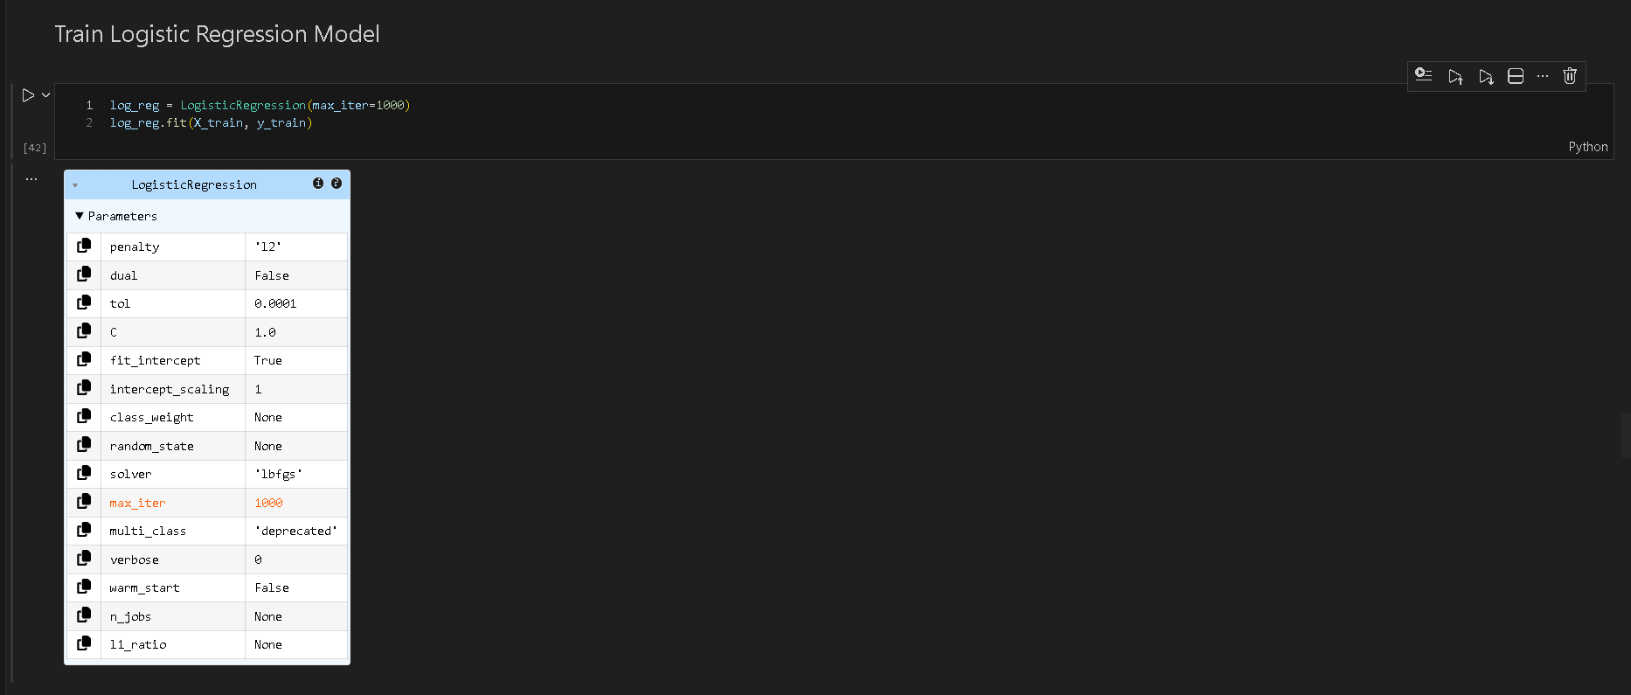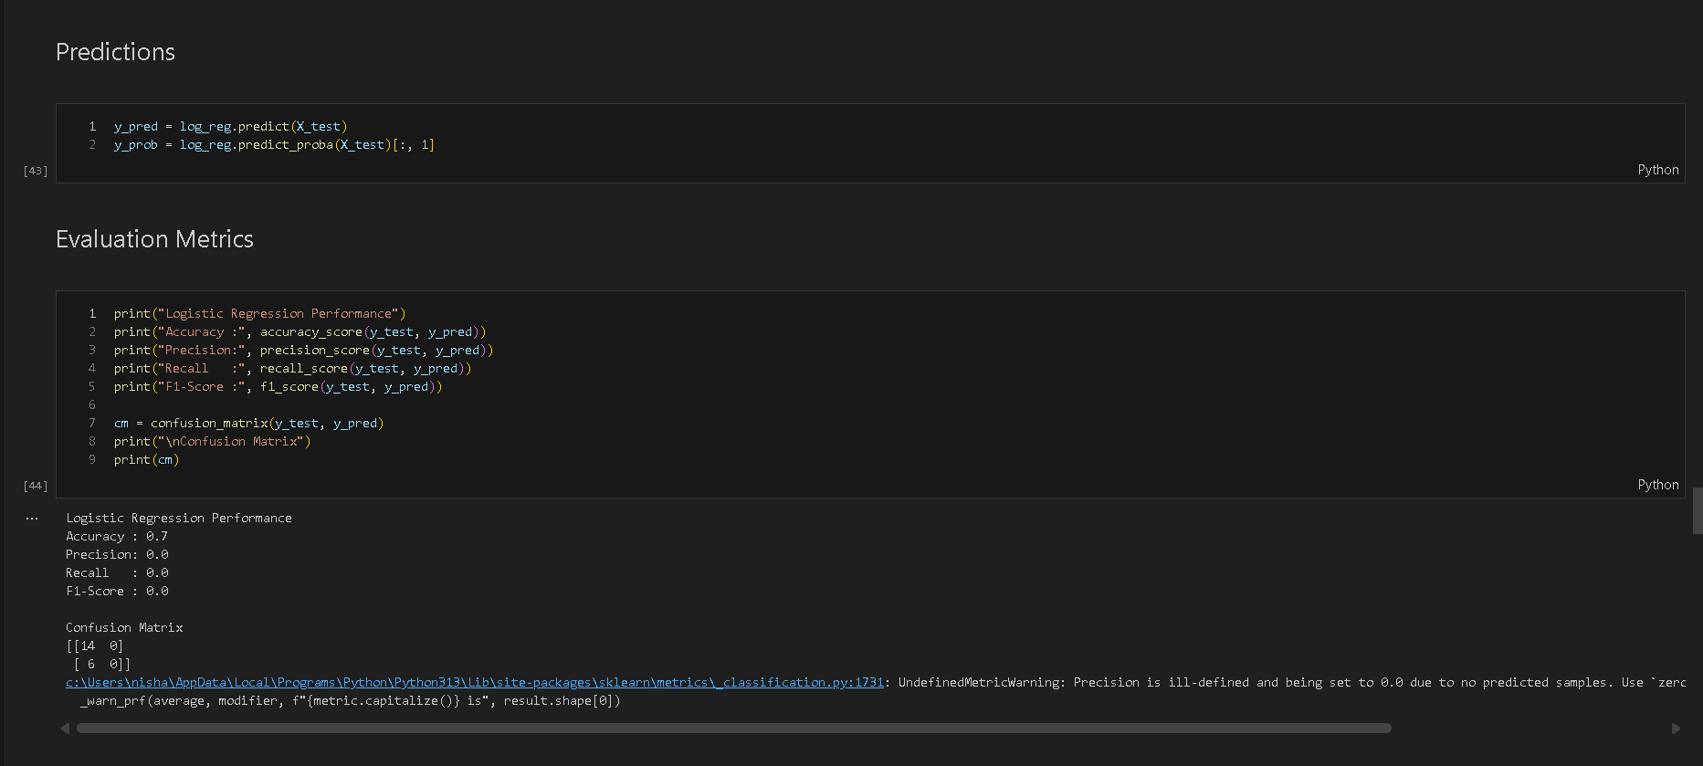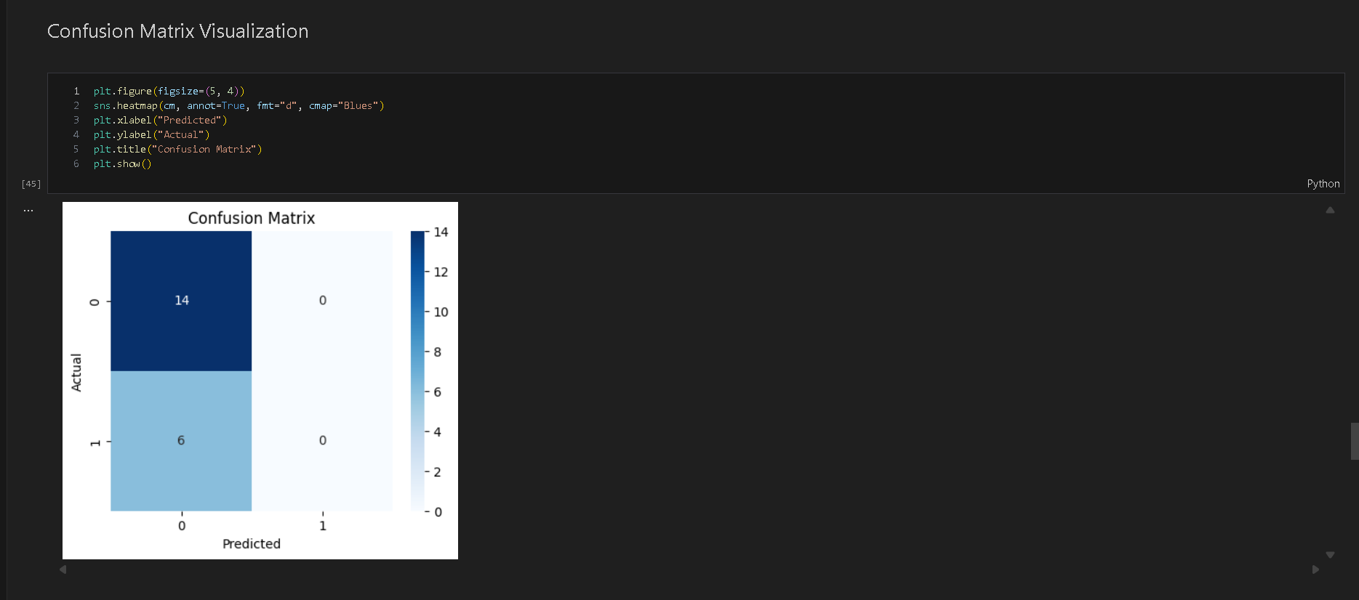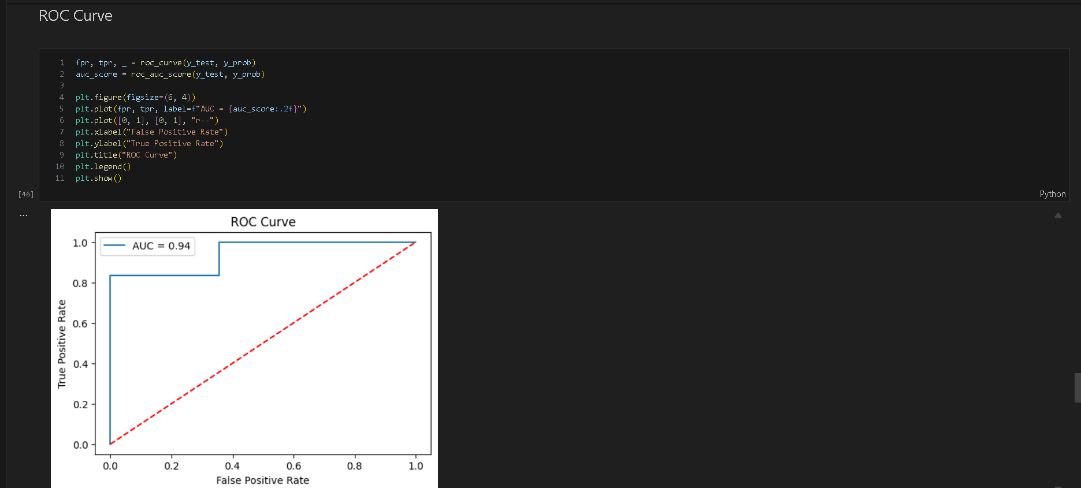
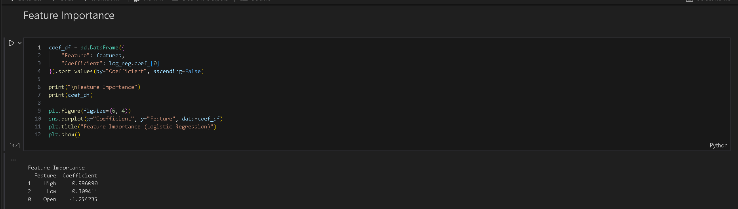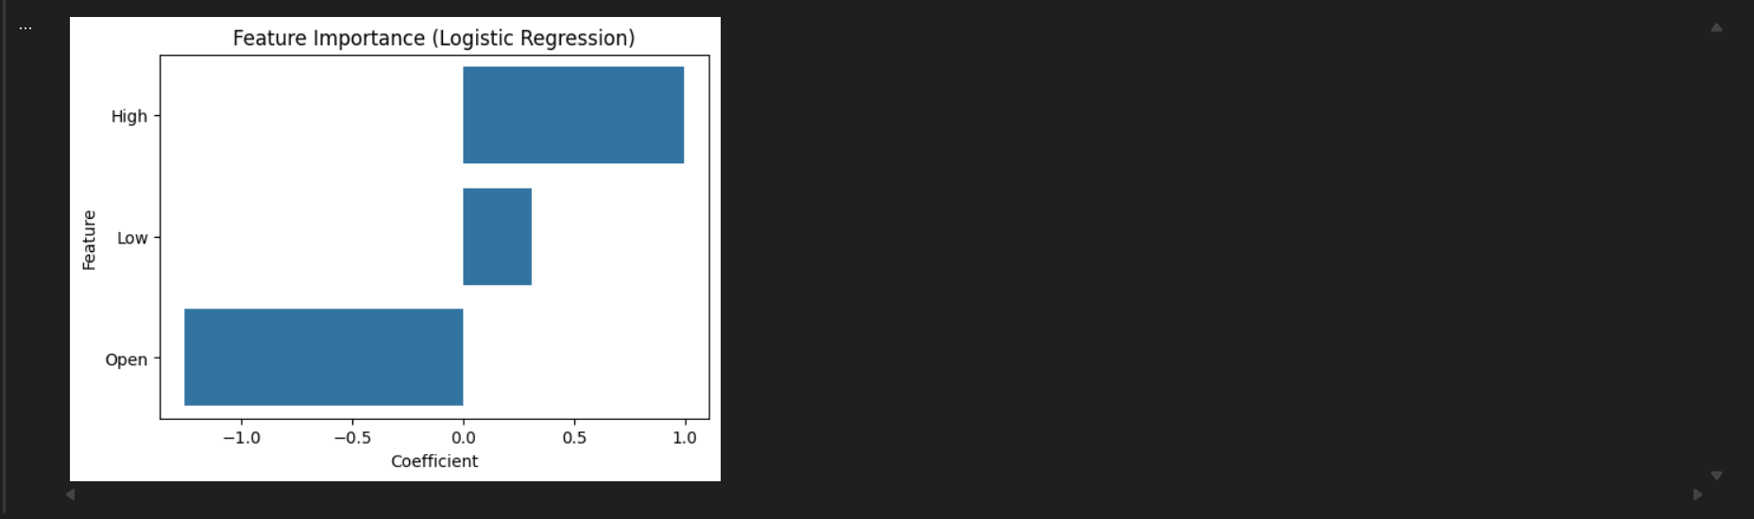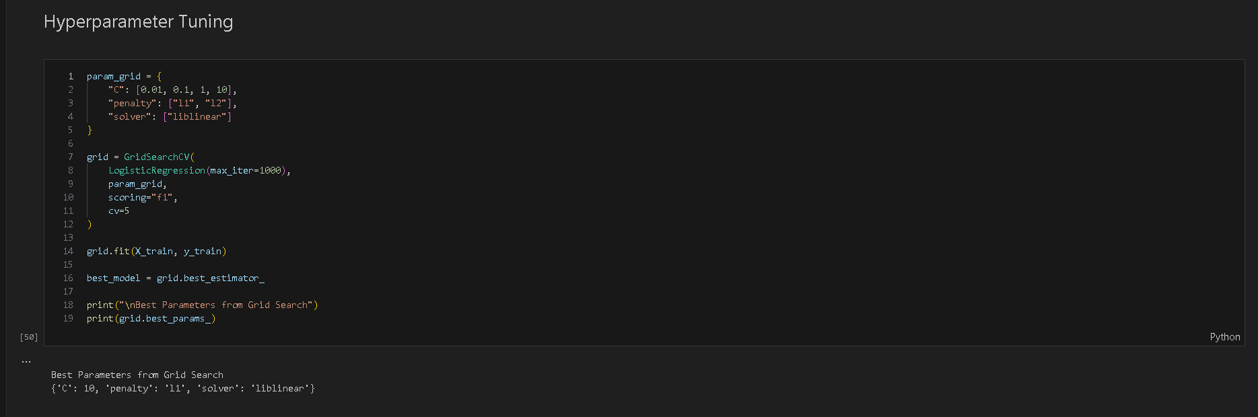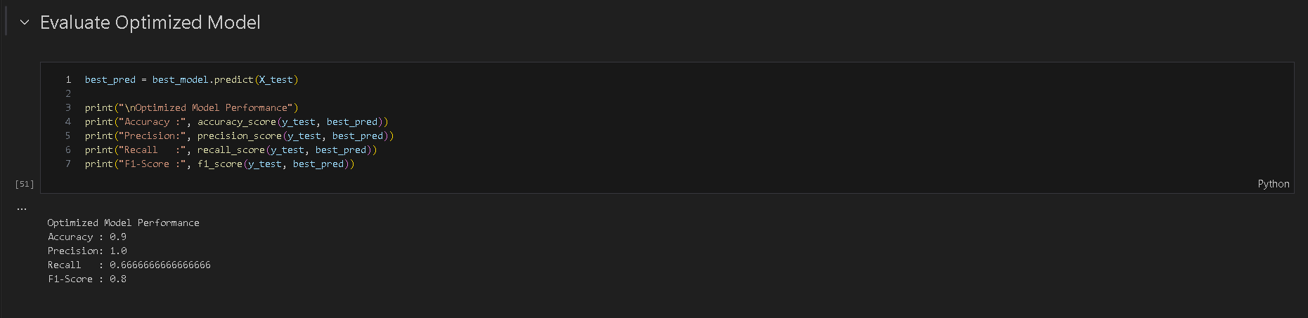

POST-LAB QUESTIONS (PROVIDE BRIEF ANSWERS TO THE FOLLOWING QUESTIONS)

Scenario 1:
- Which features had the strongest influence on ocean temperature prediction?
Historical temperature, depth, salinity, and spatial coordinates showed strongest influence due to physical ocean processes and high correlation with thermal variation.

- How did handling missing values affect model accuracy?
Imputing missing values preserved data size, reduced information loss, enabled model training, and improved prediction accuracy compared to dropping rows with missing entries.

- What improvement was observed after applying regularization?
Regularization reduced overfitting, stabilized model coefficients, improved generalization on test data, and produced more reliable performance compared to unregularized linear regression.

Scenario 2:
- How was the target class (price movement) created?
The target class was generated by comparing consecutive closing prices, labeling upward movement as 1 and downward or unchanged movement as 0.

- Which stock features were most important for classification?
Close price, open price, price range, daily price change, and trading volume were most important as they capture momentum, volatility, and market sentiment.

- How did feature scaling impact convergence and accuracy?
Feature scaling normalized value ranges, improved gradient descent convergence speed, stabilized optimization, and increased classification accuracy for scale-sensitive algorithms.

- What changes were observed after hyperparameter tuning?
Hyperparameter tuning improved accuracy, reduced bias and variance, optimized decision boundaries, and produced more consistent performance across training and validation datasets.

ASSESSMENT
Description | Max Marks | Marks Awarded
Pre Lab Exercise | 5
In Lab Exercise | 10
Post Lab Exercise | 5
Viva | 10
Total | 30
Faculty Signature

